**Introduction to machine learning**    
   
***Give a brief definition of machine learning and discuss how it differs from conventional programming.***

Machine learning differs from conventional programming because it isn’t coded to follow specific instructions. Instead, it reads data and extracts patterns of that data.

***Explain the ideas of regression and classification in supervised learning.***

Classification is labeleddata. For example, images can be labelled as a cat or dog, as these images are continually used to train the model, it will learn to classify respective images of that type.

Regression is the prediction of continuous, numerical data. For example, you could train a model to predict the price of houses based on variables such as land size and location.

***Talk about the practical uses of machine learning. You are asked to provide examples from their everyday lives where you may have come across machine learning (ML) (e.g., suggestions on streaming services, voice assistants, spam filters).***

Youtube recommends videos based on my learning history. I’d guess the model youtube uses makes connections between the videos I spend a lot of time on and then matches me with the videos other similarly connected users have spent time on.

***Give a brief explanation of how to utilize the selected machine learning technology. For example, you may make a basic project that uses the webcam to identify various objects or noises using Google's Teachable Machine.***

Googles Teachable Machine could be useful to detect different languages. You’d have to train it with a lot of samples of different languages, provided its been trained with enough data, if you want to check what language an audio clip is spoken in, it could assist you.

**ML Tool without programming:**   
**Linear Regression for predicting co2 output:**

I used Jupyter notebook to import a FuelConsumption dataset. The goal was to use linear regression to predict the output of co2 for a vehicle based on different independent variables.

1. Reading Data  
   A screenshot of a computer

   Description automatically generated
2. Assigning relevant data to a new df;
3. 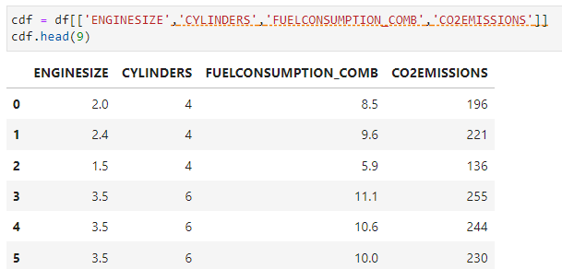
4. Slitting dataset into train and test portions;

1. Creating Linear regression model and printing the coefficient( degree of change for each variable and intercept(expected independent value if dependant value is zero)

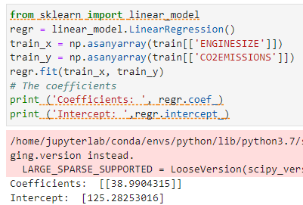

1. Evaluating performance of the model by checking Mean absolute error, Mean squared error and R2-Score

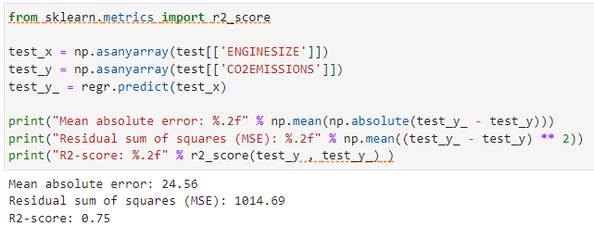

Based on the evaluation, the R2 score of .75 suggests a reasonably good fit for the model, the MSE of 1014 however suggests are large squared difference of the individual values to the predicted values. This could be due to the penalization of a few outliers as MSE penalizes large individual errors.

The resulting linear prediction vs actual values visualized:  
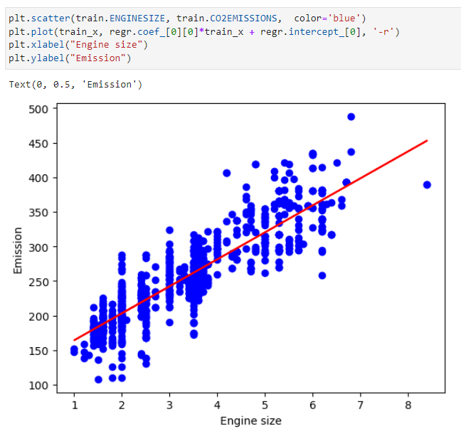

Here you can see the general trend is captured by the linear progression, hence the high R2, yet there are a few outliers aswell, hence the high MSE.